* **The Gazette**

September 2017 Monthly Publication of National Pinochle Association, Inc. Vol. XXl, Issue No. 9

**NPA Annual Tournament**

**Pittsburgh, PA**

**Aug 31 – Sept 3, 2017**

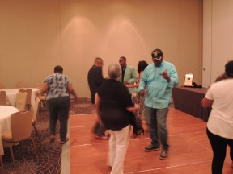 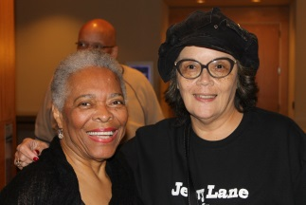 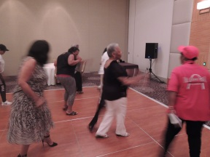 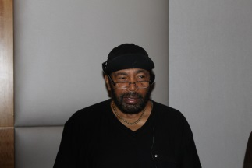

_______________________________________________________________________________________________________________

### TABLE OF CONTENTS

2017-2019 OFFICERS……………..1

PRESIDENT’S CORNER…………..1

2017 HALL OF FAME……………...3

TOURNAMENT WINNERS……….3

PLAYER OF THE YEAR…………..3

BIRTHDAYS……….......................4

RAINBOW ANNOUNCMENTS.....5

SCHOLARSHIPS…………………….6

REFEREE’S CORNER……………...7

CLASSIFIEDS...…...………….…….7



*2017-2019 NPA OFFICERS*

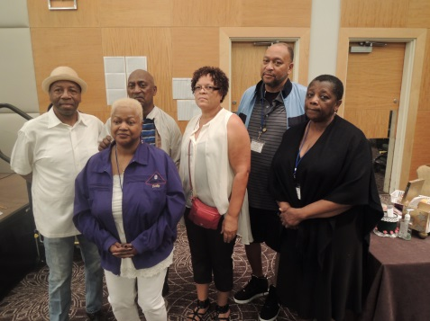

*Left to right: Jerry Lane, Dorothy Ervin, Arlene Avent, Eugene Jones, Jeanette Williams, and back: John Carmichael*

Installation of 2017-2019 NPA Officers was held on Sunday, 9 September 2017, in Pittsburgh, PA. They were sworn in by NPA Charter Member, Ms. Miriam Lucier. Our new officers are:

President: Mr. Jerry Lane

Vice President :

Mr. Eugene Jones

Recording Secretary:

Ms. Jeanette Williams

Corresponding Secretary:

Ms. Dorothy Ervin

Treasurer: Mr. J. Carmichael

National Tournament Director:

Ms. Arlene Avent

Ms. Lucier charged the membership with the following:

“**Now that our elected representatives have pledged to serve the purpose of NPA and we the membership have endorsed their leadership, let us welcome our new officers.**

**Congratulations!” (Applause)**

*PRESIDENT’S CORNER*

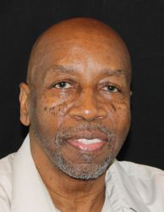

*Jerry Lane, NPA President*

Dear Fellow Pinochle Players and Associates:

Thank you for the trust and confidence you have placed in me by voting me in as your next President, National Pinochle Association, Inc.  I come to you with open ears, an eagerness to learn, receptive to new ideas, and a determination, with your help, to make NPA live up to the proclamation in its bylaws.

We have a great organization which faces all of the growth challenges (new members, charitable donations, giving back to membership, etc.) of any striving organization.  With your help, I will be instrumental in guiding NPA down this successful path.  So, feel free to let me know your concerns and ideas as I want to hear from you.

Now, let me humbly say that I am proud to be your president.  I will give all that it takes to record my tenure as one all members of NPA will be proud of. Meanwhile, I remain

Respectively yours,

**Jerry Lane**

[lanejerry1127@gmail.com](mailto:lanejerry1127@gmail.com)

*FROM THE DESK OF NTD*

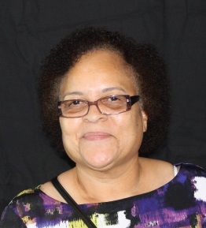

*Arlene Avent*

*National Tournament Director*

Dear Fellow Pinochle Players and Associates:

Now that I have been able to stop for a minute and catch my breath, let me just say, "Thank You!" for all that you did to make this grand event a success. Yes, it took a lot of work and a lot of hours, but seeing your joy and hearing your responses made it all worth it. And, you too did your part by being cooperative and understanding of some of the transactions (such as players being slow to get to their tables) that took place.

One good thing about all of this is that we will be doing it again soon, in about 6 months. I am already making preparations and planning for it. You plan too, please.

Meanwhile, if you have any constructive suggestions, please forward them to me. That way, our tournaments will be the best that they can be.

Now on a second note, let me "Thank You" for your voting me into office as your NPA National Tournament Director for a second term. It is a pleasure for me to serve you and be of service to you. We are a good team; and, together, we will go far.

Thanks again for all that you do and I remain

Sincerely yours,

**Arlene Avent**

[arleneavent@bellsouth.net](mailto:arleneavent@bellsouth.net)

*VIDESSA WOODS*

*(NPA PRESIDENT 2014-2017)*

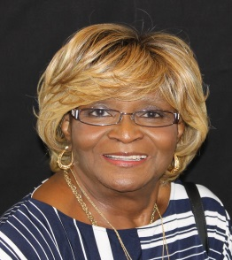

September 13, 2017

From: **Videssa A. Woods**

To: Outgoing Executive Committee & Committee Chairs

“I cannot let this time go by without letting each of you know how grateful I am to you for a job well done and your services rendered to NPA, during my administration as NPA President. Working with you, I must admit was a challenge from time to time, but so is life, and we weathered the storm. Sure, we had problems and that will continue to be, as long as we are individuals and human. But, at the end of the day, I salute you and from the bottom of my heart I send to each of you a Great Big Thank You for a Job Well Done.

To the Incoming NPA Executive Committee, I congratulate you and extend to you My Support.”

NPA SEATS NEW CHAPTERS

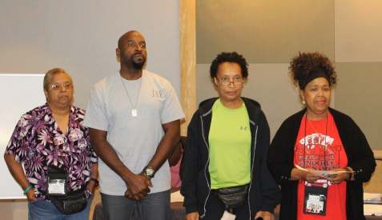

Three (3) new chapters were awarded Charters, and were seated as delegates at the Board of Directors meeting on 31 Aug 2017. Welcome to NPA:

B’More 3119 Pinochle Club – Randallstown, MD – Region 5

The Gaston Rollers Pinochle Club – Gastonia, NC – Region 4

The “Rock” Stars Pinochle Club – Decatur, GA – Region 3

*2017 HALL OF FAME*

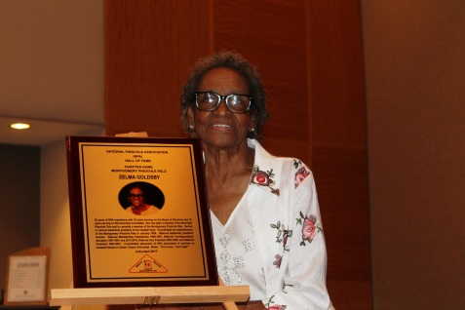

On September 2, 2017, National Pinochle Association held its 5th Annual Hall of Fame Induction Ceremony at the Annual Tournament & Convention held in Pittsburgh, Pennsylvania. Zelma Goldsby, Montgomery Pinochle Pals, former NPA President was presented into the Hall of Fame by Ricardo Randle, President of Montgomery Pinochle Pals. Suzette Goggans, PIPS of August, was inducted posthumously and presented by Thomas Vandiver, President of PIPS of Augusta. Videssa Woods, NPA President, presented the Induction Plaque and Induction Certificate and provided remarks during the Ceremony. Please visit the NPA Website to read about the contributions and accomplishments of the 2017 Hall of Fame inductees.

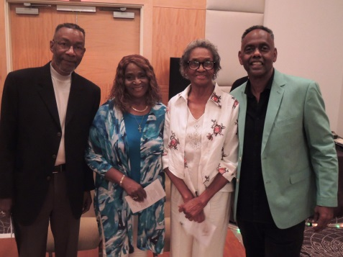

### 2017 MAIN TOURNAMENT RESULTS

The main tournament had 50 tables for a total of 200 players. The top 20 winners were:

|  |  |
| --- | --- |
| *Winners* | *Score* |
| 1 John Smith | 6,735 |
| 2 Valerie Jones | 6,645 |
| 3 Al “Smitty” Smith | 6,638 |
| 4 Connie Harper | 6,621 |
| 5 William Satterwhite | 6,487 |
| 6 Sharon Hansbrough | 6,480 |
| 7 Bruce Needham | 6,480 |
| 8 Robert Eubanks | 6,423 |
| 9Pat Bailey | 6,384 |
| 10 Lewis Taylor | 6,376 |
| 11 Carol Manning | 6,357 |
| 12 Edna Bain | 6,324 |
| 13 Bernard Dotson | 6,296 |
| 14 Herman Noah | 6,278 |
| 15 Walter Brady | 6,261 |
| 16 Frank Turpin | 6,259 |
| 17 John Bivins | 6,239 |
| 18 Richard Armstrong | 6,215 |
| 19 Ulysses Rucker | 6,206 |
| 20 Velda Elzie | 6,169 |

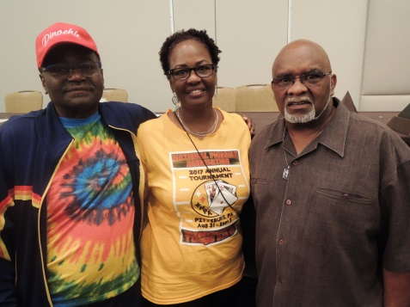

*Left to Right: John Smith, 1st place , Valarie Jones, 2nd place, Al “Smitty” Smith, 3rd place*

CONGRATULATIONS TO ALL WINNERS!

*2016 Player of the Year*

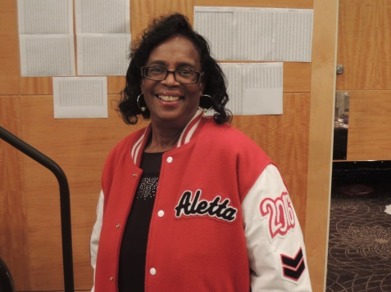

Aletta Fields, Riverdale Pinochle Club was named 2016 Player of the Year (POY). She participated in 4 sanctioned tournaments and had a total of 155 points. She is a prior winner (2013 Player of the Year) and will receive patches for her existing POY jacket. Patches will consist of a 2 Bar Chevron, Georgia State Patch with Chapter name, and a 2016 Jacket Number. The POY will also have the 2017 semi-annual and annual tournament fees waived. Congratulations to Aletta for making NPA history.

*Zelma Goldsby*

*Chairperson, R&E Committee*

*2017 Player of the Year*

The results of the Annual Tournament held in Pittsburgh are in. Al Smith, NC Sandhill and William Satterwhite, USA Society, were the only NPA members that moved forward in the point standings for Player of the Year. Al Smith is now tied with Jay Buxton with each player earning a total of 175 points. The below point standings reflect those top players that can numerically win Player of the Year by participating in the Columbus Day Tournament. A complete listing of the Player of the Year rankings and validation can be found on the NPA website. The final sanctioned tournament will be held in Greensboro, NC. In order to win Player of the Year a member must have participated in four sanctioned tournaments and receive the total number of points. The contest for Player of the Year is still too close to call.

*POINT STANDING*

Name Points

|  |  |
| --- | --- |
| Jay Buxton | 175 |
| *(Empire State)* |  |
| Al Smith | 175 |
| *(NC Sandhill)* |  |
| Minnie Cooper | 150 |
| *(Pinochle Champs)* |  |
| John Smith | 150 |
| *(Great Lakes)* |  |
| Jimmy Williams | 135 |
| *(Birmingham Pinochle Club)* |  |
| Clarence Fleming | 125 |
| *(NC Sandhill)* |  |
| Valerie Jones | 125 |
| *(NC Sandhill)* |  |
| Ann Hill | 100 |
| *(Tidewater Knucks )* |  |
| Terrance Hansbrough | 100 |
| *(The Memphis Connection)* |  |
| Troy Briscoe | 100 |
| *(DC Players)* |  |
| John Mosley | 90 |
| *(NC Sandhill)* |  |
| William Sattlewhite | 90 |
| *(USA Pinochle Society)* |  |
| James Parker | 75 |
| *(Trump Tight)* |  |
| Charles Thomas | 75 |
| *(Pinochle Champs)* |  |
| Connie Harper | 75 |
| (*Metro)*) |  |
| Lashadra Cookie” Adcox | 75 |
| Birmingham Pinochle Club |  |

**

### Kings & Queens Born in September

|  |  |
| --- | --- |
| Maurice Armster | Sep 11 |
| Johnny Benitez Jr | Sep 20 |
| Lorraine Bridges | Sep 13 |
| Mamie Brown | Sep 20 |
| Jimmy Brown | Sep 20 |
| Ruby Bullock | Sep 22 |
| Carolyn Canada | Sep 24 |
| Hubert T. Collins | Sep 14 |
| Greg Fairbanks | Sep 16 |
| Bill Fenrich | Sep 1 |
| James Fields | Sep 5 |
| Yvonne Ford | Sep 18 |
| Harriet Fultz | Sep 18 |
| Shawn Groomster | Sep 14 |
| Donald Hall | Sep 19 |
| Elliott Harris | Sep 23 |
| Gwen Harris | Sep 11 |
| Hugh Holder | Sep 11 |
| Bennie Jackson | Sep 23 |
| Phyllis Jenkins | Sep 7 |
| Anderson Johnson | Sep 20 |
| Katrina Johnson | Sep 18 |
| Raziki Johnson | Sep 4 |
| Valerie Jones | Sep 25 |
| Ruby Lewis | Sep25 |
| Brenda Mallard | Sep 19 |
| Anna Martin | Sep 19 |
| Irvina Mayner | Sep 10 |
| Bill McBride | Sep 2 |
| Gloria McKinney | Sep 24 |
| Rosetta McMurray | Sep 4 |
| Reginald Miles | Sep 23 |
| Jack Morgenroth | Sep 25 |
| Darrell Moss | Sep 5 |
| Ella Murphy | Sep 19 |
| Donna Pace | Sep 3 |
| Edward J Parker | Sep12 |
| Thomas Parks | Sep 4 |
| Flora Peterson | Sep 16 |
| Marvin Raines | Sep 29 |
| Esther Robinson | Sep 20 |
| Alice Scott | Sep 17 |
| James Simon | Sep1 |
| June Smith | Sep 26 |
| Linda Tate | Sep 17 |
| Woddell Thomas | Sep 1 |
| Hayward Thompson | Sep 6 |
| Charles Washington | Sep 22 |
| Patricia Williams | Sep 4 |
| Cheryl Williamson | Sep 2 |
| Karen Young | Sep 27 |

### Kings & Queens Born in October

|  |  |
| --- | --- |
| Darryl Anderson | Oct 28 |
| Kirby Ray Anderson | Oct 3 |
| Lary Arvila | Oct 27 |
| William Bowers | Oct 10 |
| Sylvia Burke | Oct 21 |
| John Calloway | Oct 2 |
| Willie Collins | Oct 24 |
| Robert Cooper | Oct 15 |
| Joe Cummings | Oct 30 |
| Roy Doss | Oct 15 |
| Vielka Downer | Oct 27 |
| Cin-dee Dunn | Oct 31 |
| William Evans | Oct 30 |
| Roosevelt Freeman | Oct 27 |
| Arthur Gainer | Oct 3 |
| Thelma Gregory | Oct 16 |
| Zora Hargrave | Oct 31 |
| Gary Harrison | Oct 19 |
| William "Bill" Harrod | Oct 19 |
| Autry Hasberry | Oct 9 |
| Richard Hawkins | Oct 22 |
| Bernard Jackson | Oct 14 |
| Curtis Jarrell | Oct 28 |
| Charlee Johnson | Oct 10 |
| Alpheus B Jones | Oct 10 |
| Patricia Jones | Oct 18 |
| Rollie Kosteeinsher | Oct 10 |
| Bobby Mackey | Oct 23 |
| Earnestine Martin | Oct 6 |
| Curtis McGee | Oct 16 |
| Lois Mitchell | Oct 23 |
| Herbert Morris | Oct 26 |
| Jennifer Newby | Oct 30 |
| LaTondra Okeke | Oct 23 |
| Devontae Pettiway | Oct 24 |
| Patricia Peyton | Oct 15 |
| John Pitts | Oct 17 |
| Phyllis Ransome | Oct 27 |
| William Ray | Oct 28 |
| Valerie Revere | Oct 25 |
| Mike Singleton | Oct 22 |
| Lonnie Smith | Oct 30 |
| James Thomas | Oct 2 |
| Joyce Thomas | Oct 2 |
| Noreen Thomas | Oct 17 |
| Barbara R Thomas | Oct 26 |
| Martha Vaughn | Oct 12 |
| Vivian Wallace | Oct 6 |
| Michael White | Oct 29 |
| James Williams | Oct 9 |
| Sandra Zastrow | Oct 24 |
|  |  |



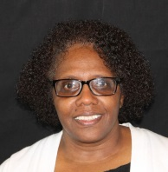

*Rosetta McMurray, Chairperson*

*Rainbow Committee*

Please keep the below NPA members and their families lifted in your prayers.

***MEMBERS’ DEATH***

None

***FORMER MEMBER’S DEATH***

Alva Sanks-Weeks - former NPA Secretary and Historian, and former member of Columbus Pinochle Club. Condolences can be sent to her daughter, Latesha Sanks-Kenan. Her mailing address is 2411 Coy Drive Copperas Cove, TX 76522.

***MEMBERS’ ILLNESS***

**James "Bernie" Walker of Pinochle Champs is at Bradford Oak Rehab Center. His address is 3709 Bangor Street SE Washington, DC 20020; Telephone: (202) 438-9959.**

**Dr. Robert Spivey of Bucks and Does Double Deck Club. His address is 241 N. 22nd Street Columbus, OH 43207.**

**Chrystabell "Chris" King of Montgomery Pinochle Pal is in Rehab in Montgomery. Her home address is 4327 Lawnwood Drive Montgomery, AL 36108.**

**of Baltimore Bidwell. His address is 3309 Southgreen Road Baltimore, MD 21244.**

**Jesse Oliver of 31-19 Pinochle Club is in Rehab. His address is 2114 Ridgemont Road Richmond, VA 23224 (804) 231-5609.**

**Dorothy Coles of 31-19 Pinochle Club is in the hospital. Her address is 2114 Ridgemont Road Richmond, VA 23224 (804) 231-5609.**

**Thomas (T.C.) Johnson is in the hospital. His address is 1514 Wallace Street, Richmond, VA 23220. (804) 350-0868.**

**Bobby Mackey of Victor Valley Pinochle Club is in the hospital. His address is P.O. Box 3698 Victorville, CA 32393.**

**Kathy Hubbard of Bid or Pass Pinochle Club is recovering from a fall. Her address is 14732 Boyce's Cove Drive, Midlothian, VA 23112.**

**Bill McBride of Bid or Pass Pinochle Club is ill. His address is 13109 Random Road, Chester, VA**

**Alvira Thompson of Riverdale Pinochle Club is in ICU at Cleveland Medical Center in Cleveland, Ohio. Family is asking for prayers from NPA members. Family is requesting no visitors while Alvira is in ICU. Her mailing address is 178 Moury Ave Apt #3717 Atlanta, GA 30315.**

**Edward Perry of Atlanta Pinochle Association is at home recovering from surgery. His address is 883 Timbervale Lane Lithonia, GA 30058.**

***FAMILY MEMBER ILLNESS***

None

***FAMILY MEMBERS’ DEATH***

None

**Please Email:**

[**rosettamcmurray@bellsouth.net**](mailto:rosettamcmurray@bellsouth.net) **or call (706) 289-6471 to notify me of any NPA member’s or family member’s death or illness.**

***Information needed when reporting an illness or death of an NPA Member or Family member***

* Name of sick/deceased member/family member
* Sick/deceased member/family member Club name
* Address to mail Get-well/sympathy card
* Telephone Number
* If in hospital, name of hospital, room number and hospital telephone number

Photos from the 2017 NPA Memorial Service

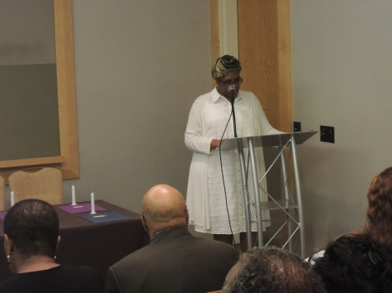

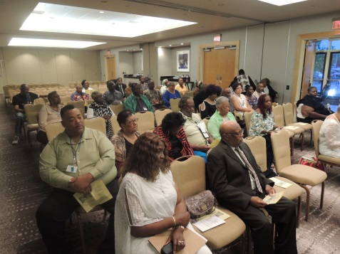

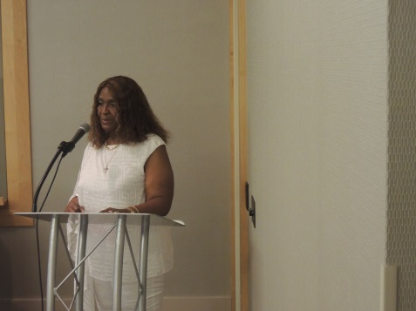

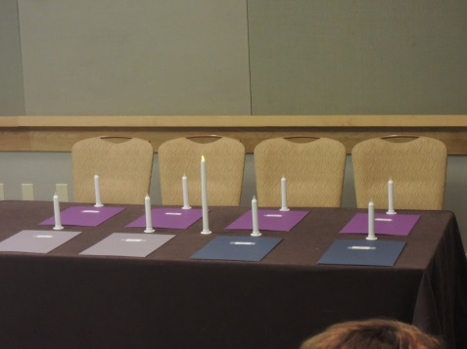



*By Roberta Johnson, Chair Scholarship Committee*

As the appointed NPA scholarship chairperson, I was pleasantly surprised and thoroughly delighted with the portfolios which were submitted by our young college bound students.  As chairperson, borrowing some ideas from Gwen Harris and Lester McCray, I tried to raise the bar for persons applying for scholarship awards.  Not only did our young people meet the demands established in the scholarship application and expectations I set for them, they exceeded them.  This is not to “throw shade” on previous applicants, since some of them also submitted great portfolios.  The level of professionalism displayed is the kind of performance we desire for our youth.  **Congratulations** to all the recipients and congratulations to you who instill in our young people the importance of pursuing excellence.  I only regret that so many of us did not have an opportunity to peruse the portfolios that were available at our annual convention.  These students who submitted portfolios for 2017 as well as those for 2016 worked exceptionally hard in school, as evidenced by grades, test results, and involvement in extracurricular activities.  We need to be proud of our youth and continue to encourage them to excel.  Please continue to encourage them not to settle for mediocracy.  They are our future and that future has its own set of challenges that they must be ready to meet.

**Kudos to 2017 NPA Scholarship Recipients:**

Charlena Brassell

*Granddaughter of Patricia Brassell-Russ Raiders of Detroit*

Eric Medley Jr.

*Grandson of Joyce Medley-Amelia Tri-Cities*

Naomi Jenkins

*Granddaughter of Thomas and Phyllis Jenkins-Aces Around*

Akare Elon Anthony Burks

*Grandson of Janette Grayson-Queen City Players*

NPA DONATES TO HURRICANE VICTIMS

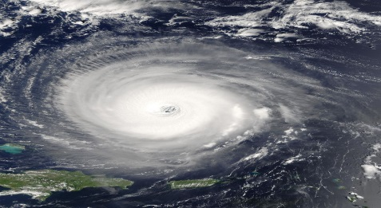

NPA’s Board of Directors voted that this year’s charity donation should be given to an organization that provides disaster relief to the victims of Hurricane Harvey. $3,000 will be given to The Salvation Army.

The Salvation Army has been supporting those in need without discrimination for more than 135 years in the U.S.

The Salvation Army has served survivors of every major national disaster since 1900. *The Salvation Army does not place an administrative fee on disaster donations. During emergency disasters, 100 percent of designated gifts are used to support specific relief efforts.*

For more information, go to [www.SalvationArmyUSA.org](http://www.salvationarmyusa.org/)



REFEREE’S CORNER

Tournament Rule:

The only person who can ask for the closed book to be turned back over before the next card has been played is the person who might have made an error.

True or False?

Answer: False

Any player can ask to see the closed book. In accordance to Section 2.7 of NPA’s Tournament Manual: “*A player may only request to “see” the last book before the first (1st) card of the next book is played.* ***Only the player who requested to see or “review” the book may change their card to prevent a forced renege.*** *Therefore, there is no protecting the partner. There can be* ***NO DISCUSSION*** *during the review of the book such as: “what’s trump”, “who played what”, “what led”, etc.”*

**Send responses, questions or comments to** [zetabj@hotmail.com](mailto:zetabj@hotmail.com)

 **Life until the next time,**

**Beverly J. Taylor**

# fun.jpgUPCOMING TOURNAMENTS

**2017 SANCTIONED**

Oct 6-8………………Charlotte, NC

*(Hosted by Queen City Players)*

2017 NON-SANCTIONED

Nov 3-5……………….Hampton, VA

*(Hosted by* [*Tidewater Knucks*](http://www.npapinochle.org/Tournaments_Non%20Sanctioned/2017_TIDEWATER_KNUCKS_FLYER.pdf) *)*

Dec 1-3………………...Augusta, GA

*(PIPS’ Tournament & Toy Drive)*

**2018 SANCTIONED**

Mar 22-25…...Robinsonville, MS

*(NPA Semi-Annual Tournament)*

*CLASSIFIEDS*

**Vulcan Princess, Inc. Screen printing & embroidery, Contact Frank Turpin: 404-219-3376 or**

[**tuako3@aol.com**](mailto:tuako3@aol.com)

Learn the game using the teaching tool ‘Pinochle Mat’ developed and distributed by an experienced player. Call Mrs. L. Walker at 305-255-7782 for further information.

Need a caterer for your every need? EDC (Edna’s Delectable Cuisine) is waiting for your call:

404-767-1024 or email [brownednaw@yahoo.com](mailto:brownednaw@yahoo.com)

For all your cruise vacation needs, contact Val Culpepper @ Hooked on Cruises [770-739-7860](tel:(770)%20739-7860).

*NPA WEBSITE*

The web address is:

<http://www.npapinochle.org/>

All information to be posted on the website must be emailed to Zelma Goldsby, Chairperson – R&E Committee for approval.

[zgoldsby@aol.com](mailto:ricardorandle@bellsouth.net)

Webmaster:

**Maxim Multi Media, LLC**



*NPA NEWSLETTER*

The Gazette is distributed by the Research &Education Com.

Clubs and Members are invited and encouraged to submit articles for sharing. Articles should be forwarded to

:

Shirley Bevel, Editor at:

npagazette@gmail.com

404-803-8702 (Cell)

*NPA ONLINE PHOTO DIRECTORY*

NPA members’ photos can be accessed at: [http://www.picture-directory.com](http://www.picture-directory.com/)